SELECT E.emp_no, E.first_name, E.last_name, COUNT(*)

FROM employees E INNER JOIN salaries S

ON E.emp_no = S.emp_no

WHERE S.salary > (SELECT AVG(Sa.salary) from salaries Sa)

GROUP BY E.emp_no, E.first_name, E.last_name

;

**QUERY 1**: SELF-JOIN

People in same company:

select A.first_name, A.last_name, A.company, B.first_name, B.last_name from user_no_index.user A, user_no_index.user B where A.first_name <> B.first_name and A.company = B.company

select A.first_name, A.last_name, A.company, B.first_name, B.last_name from user_with_index.user A, user_with_index.user B where A.first_name <> B.first_name and A.company = B.company

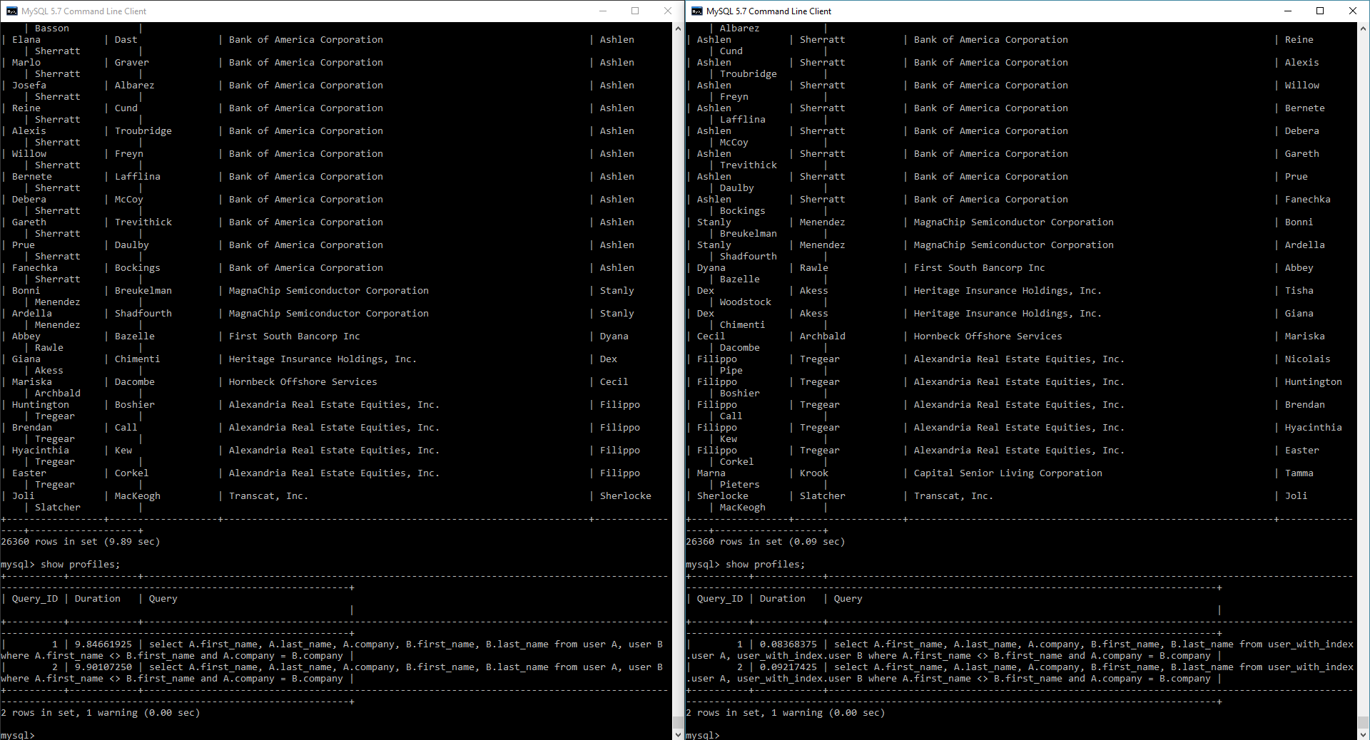

**QUERY 2**:

User info with country name

select A.first_name, A.last_name, A.company, A.country_code, B.country from user_no_index.user A left outer join user_no_index.country B on A.country_code = B.country_code order by A.first_name

select A.first_name, A.last_name, A.company, A.country_code, B.country from user_with_index.user A left outer join user_with_index.country B on A.country_code = B.country_code order by A.first_name

Company:

CREATE TABLE `company` (

`company` varchar(100) NOT NULL,

`street_number` varchar(45) NOT NULL,

`street_name` varchar(45) NOT NULL,

`city` varchar(45) NOT NULL,

`state` varchar(45) NOT NULL,

`country` varchar(45) NOT NULL

) ENGINE=InnoDB DEFAULT CHARSET=utf8;

**QUERY 3:**

Display user’s info with his company details

select A.first_name, A.last_name, A.company, B.street_number, B.street_name, B.city, B.state, B.country

from user_no_index.user A, user_no_index.company B

where A.company = B.company

order by A.first_name

select A.first_name, A.last_name, A.company, B.street_number, B.street_name, B.city, B.state, B.country

from user_with_index.user A, user_with_index.company B

where A.company = B.company

order by A.first_name

index_company_1 : company of user_with_index.user

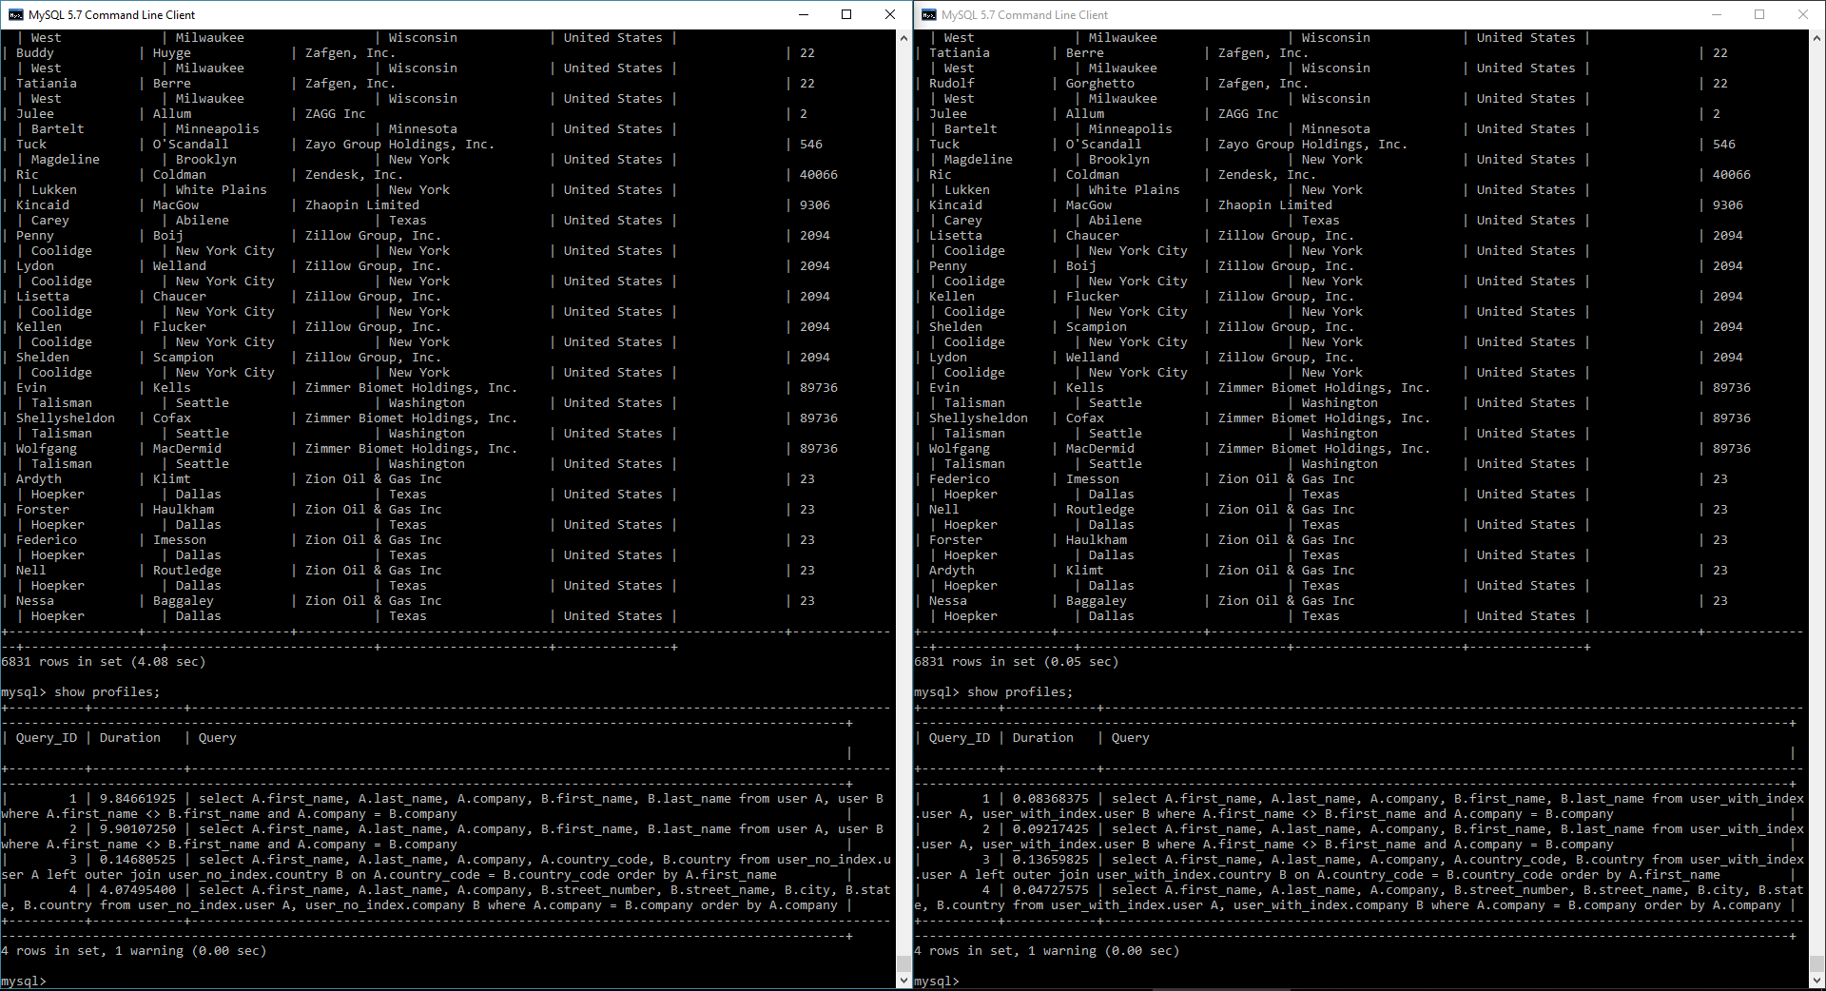

**QUERY 4:**

Get all companies which are located on the same street of the city in USA.

select distinct A.company, A.street_number, A.street_name, A.city, A.state from user_no_index.company A, user_no_index.company B where A.company <> B.company and A.street_name = B.street_name and A.city = B.city order by state, city, street_name

select distinct A.company, A.street_number, A.street_name, A.city, A.state from user_with_index.company A, user_with_index.company B where A.company <> B.company and A.street_name = B.street_name and A.city = B.city order by state, city, street_name

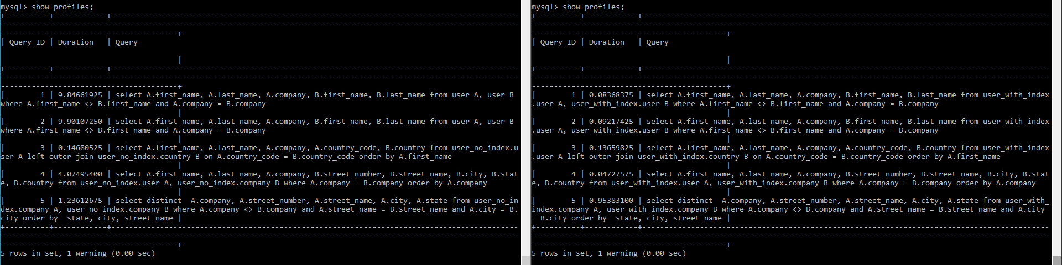

user_no_index:

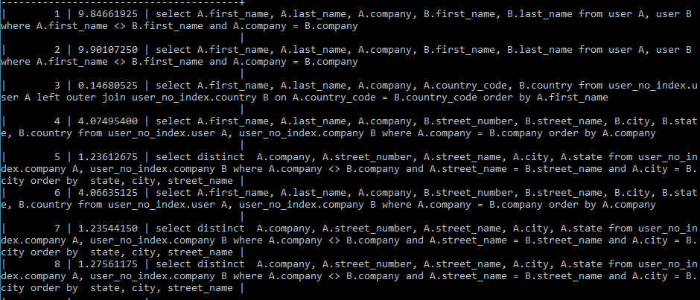

User_with_index:

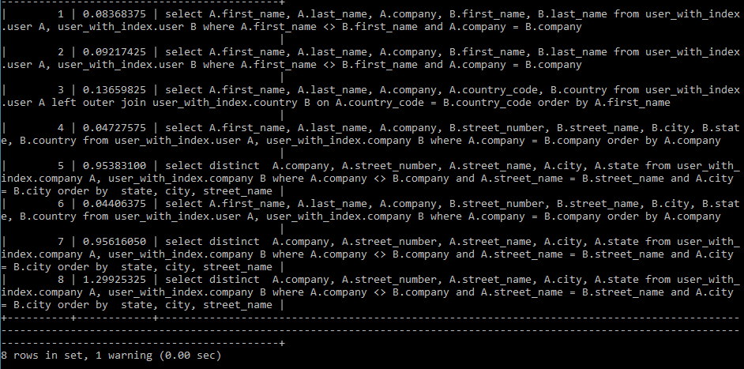

5: index on company, street_name, city

6: repeated query 3

7: index on company, street_name

8: index on company only - no performance improvement

**QUERY 5:**

Display Male to Female ratio amongst all employees based on country

select B.country, count(case when A.gender = 'Male' then 1 end) as Male, count(case when A.gender = 'Female' then 1 end) as Female from user_no_index.user A, user_no_index.country B where A.country_code = B.country_code group by B.country order by A.country_code;

select B.country, count(case when A.gender = 'Male' then 1 end) as Male, count(case when A.gender = 'Female' then 1 end) as Female from user_with_index.user A, user_with_index.country B where A.country_code = B.country_code group by B.country order by A.country_code;

Index on user’s country code





Index on user’s and country’s country code:



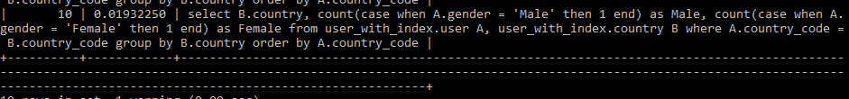

**QUERY 6:**

Get all the stock information of user’s company stocks

Index on user’s company

select A.first_name, A.last_name, A.company, B.stock_sector, B.stock_symbol, B.stock_market_cap from user_no_index.user A, user_no_index.stock B where A.company = B.company and B.stock_sector in ('Technology', 'Finance');



select A.first_name, A.last_name, A.company, B.stock_sector, B.stock_symbol, B.stock_market_cap from user_with_index.user A, user_with_index.stock B where A.company = B.company and B.stock_sector in ('Technology', 'Finance');



Index on user’s company and stock’s company



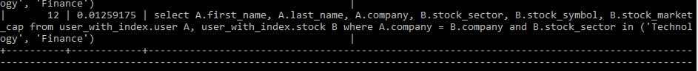

Index on user’s company, stock’s company, stock’s sector

